Would you like to be a future leader?
A better leader?

Here’s your chance…
Civilian Development Education (CDE) and Civilian Strategic Leader Program (CSLP) will help you develop the skillsets needed to accomplish this goal.

The Civilian Developmental Education (CDE) Office will host webcasts about opportunities for the upcoming AY23 CDE cycle.
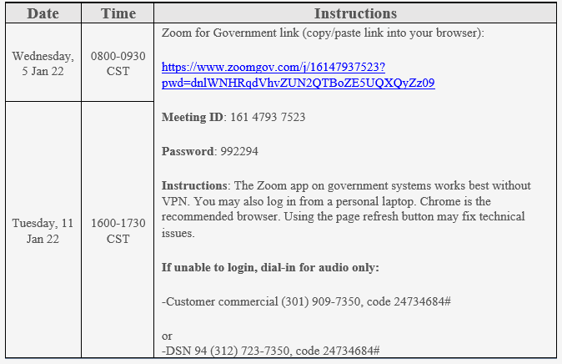
Details on all CDE opportunities are available on the myPers Civilian Force Development Home Page (https://mypers.af.mil/app/categories/c/549/p/2).
Applications must be submitted through MyVector (https://myvector.us.af.mil/myvector), applicants, reviewers, and endorsers need to register/access MyVector via Google Chrome.
Applicants must self-nominate by 25 Feb 2022; endorsements are required no later than 18 Mar 2022. Please stay informed of, and abide by, any internal deadlines established by your organization.
For more information, please contact Jamina Caldera - Civilian Training Manager at jamina.caldera@spaceforce.mil or afpc.civiliandevelopment.cde@us.af.mil.

